Information about authors, keywords, and abstract are uploaded via the electronic submission system. Read more about this here.
** Note: The main part of the article is attached on the electronic edition website in the document format .doc, .docx. The article should contain from 4 to 6 thousand words.

Introduction
This section begins with a description of the research object, and then the author formulate the research relevance. It is necessary to specify the scientific problem and indicate its correlation with the tasks that need to be solved within the framework of the author's research.

Literature review
This section provides an overview of the world literature, confirming the absence of a solution to this problem in the literature sources and / or indicating the experts on whose research this work is based. It is necessary to analyze the results obtained by the authors, as well as to indicate how this correlates with the research being conducted within the framework of your article.

Materials and methods
This section describes in detail the selected research method. You should present the methods in such a way that another scientist would be able to reproduce your research and get similar results. In other words, this section provides detailed information about the study sequence (step-by-step). In addition, it is important to pay attention to the selection rationale of the methods used.

Results
The information in this section should be arranged in accordance with the previously proposed algorithm (stages) from the Materials and Methods section. It is recommended to present the results mainly in tables, graphs and other illustrations. This section also includes an analysis of the results obtained and their interpretation.
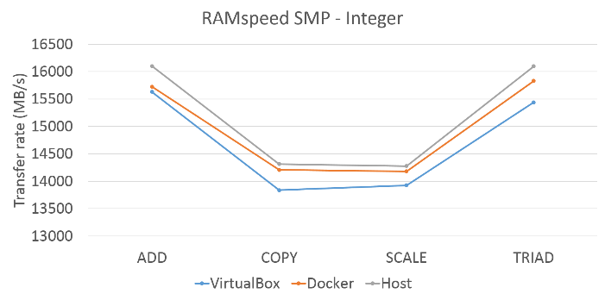 | 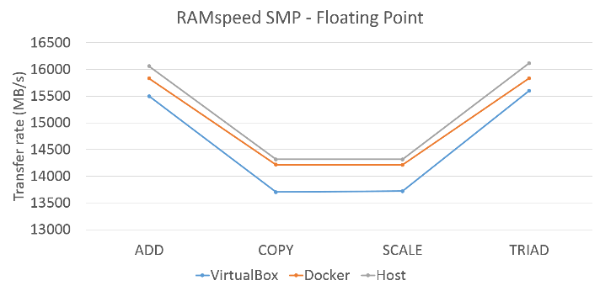
(a) | (b)
Figure 2 Memory performance result: (a) Integer; and (b) Floating point

Table 1 Number of receptors in each container
Experiment | Container | Receptor
1 | 50 | 28
2 | 100 | 14
3 | 150 | 9
4 | 200 | 7
5 | 250 | 5

Formulas are typed using the built-in formula editor. Formula characteristics:
- font — Times New Roman;
- size: ordinary type — 12 pt, subject-heading — 9 pt, small subject-heading — 7 pt,
large type — 14 pt, small type — 10 pt (to change the parameters, click the "Size" tab ==> "Define" and set the essentials);
- font type: variable and lowercase greek — italics, the rest — straight lines.
$x=\frac{-b±\sqrt{b^{2}-4ac}}{2a}$ (1)
It’s necessary to perform numbered and bulleted lists using the appropriate MS Word tools, not manually.

Discussion
This section is characterized by the authors' critical thinking on their research. It is necessary to explain here as precisely as possible the meaning of the results obtained in the previous section and to demonstrate how they relate to other studies presented in the international science stage.

Conclusion
This section summarizes the results of the study. We recommend to present conclusion in the form of numbered outputs that briefly formulate the scientific results of the article.

Acknowledgements
This section is not essential, it expresses gratitude for the financial, informational and other support provided to the authors during the writing of this article (for example, grants, subsidies, etc.).

References
The list of references should contain at least 25 sources. You should arrange all sources in the order of their mention in the text. The list of references includes only scientific articles, collections of articles, monographs, collections of conferences on the topic of research. References to analytical reports, Internet resources, legislative acts and government resolutions, and other sources that are not scientific, are made using footnotes and are NOT included in the list of references. Only one English-language list of references should be prepared for the article. The share of articles in scientific journals should be more than 80% in the list of references. All sources must have a DOI.
For exception these kind of mistakes, we strongly recommend to use the free Mendeley software. The style for the English-language list of references can be set in Mendeley Desktop. To do this, use the menu items View – Citation Stile – More Stiles – Get More Styles – Download – Elsevier - Harvard (with titles) in Mendeley Desktop. The text of the article should contain links to all sources from the list of references.
For more information about the requirements for the list of references, see this link.

Example of mentioning sources in the text:

(Abd Alla et al., 2020; Alola and Akadiri, 2021; Farr and Faber, 2018; Herath, 2019; Lerman et al., 2021; Mitić et al., 2020; Østergaard et al., 2020; Rodionov et al., 2020; Rodionov and Velichenkova, 2020; Skhvediani and Kudryavtseva, 2020; Tereshko et al., 2020)

Example of references:

Abd Alla, S., Bianco, V., Tagliafico, L.A., Scarpa, F., 2020. Life-cycle approach to the estimation of energy efficiency measures in the buildings sector. Appl. Energy 264, 114745. https://doi.org/10.1016/j.apenergy.2020.114745
Alola, A.A., Akadiri, S.S., 2021. Clean energy development in the United States amidst augmented socioeconomic aspects and country-specific policies. Renew. Energy 169, 221–230. https://doi.org/10.1016/j.renene.2021.01.022
Farr, J.V., Faber, I., 2018. Engineering Economics of Life Cycle Cost Analysis, 1st Editio. ed. CRC Press, Boca Raton. https://doi.org/10.1201/9780429466304
Herath, H.S.B., 2019. Postauditing and Cost Estimation Applications: An Illustration of MCMC Simulation for Bayesian Regression Analysis. Eng. Econ. 64, 40–67. https://doi.org/10.1080/0013791X.2018.1498961
Lerman, L.V., Gerstlberger, W., Ferreira Lima, M., Frank, A.G., 2021. How governments, universities, and companies contribute to renewable energy development? A municipal innovation policy perspective of the triple helix. Energy Res. Soc. Sci. 71, 101854. https://doi.org/10.1016/j.erss.2020.101854
Mitić, P., Kostić, A., Petrović, E., Cvetanovic, S., 2020. The Relationship between CO2 Emissions, Industry, Services and Gross Fixed Capital Formation in the Balkan Countries. Eng. Econ. 31, 425–436. https://doi.org/10.5755/j01.ee.31.4.24833
Østergaard, P.A., Duic, N., Noorollahi, Y., Mikulcic, H., Kalogirou, S., 2020. Sustainable development using renewable energy technology. Renew. Energy 146, 2430–2437. https://doi.org/10.1016/j.renene.2019.08.094
Rodionov, D., Mokeeva, T., Aliev, I., 2020. Development of an Optimization Model for the Formation of an Innovative Project Portfolio per Stages of the Life Cycle, in: Proceedings of the 2nd International Scientific Conference on Innovations in Digital Economy: SPBPU IDE-2020. ACM, New York, NY, USA, pp. 1–5. https://doi.org/10.1145/3444465.3444520
Rodionov, D., Velichenkova, D., 2020. Relation between Russian Universities and Regional Innovation Development. J. Open Innov. Technol. Mark. Complex. 6, 118. https://doi.org/10.3390/joitmc6040118
Skhvediani, A., Kudryavtseva, T., 2020. Effectiveness Assessment of Investments in Robotic Biological Plant Protection. Int. J. Technol. 11, 291–319. https://doi.org/https://doi.org/10.14716/ijtech.v11i8.4528
Tereshko, E., Romanovich, M., Rudskaya, I., 2020. Readiness of Regions for Digitalization of the Construction Complex. J. Open Innov. Technol. Mark. Complex. 7, 2. https://doi.org/10.3390/joitmc7010002

